The main research question of this problem was “What are the natural groupings of elements (clusters) that create different fondue recipes?” Since this study is a preliminary analysis and the expectation is to find natural groupings of fondue recipes, I would recommend using Agglomerative Clustering. This method is best used when there are variables of interest used to find groups with similar data points (short distances). This technique is usually conducted in exploratory data analysis when there are no labels that exist for the groups, i.e. there is no variable that determines whether row x belongs to recipe y. There are multiple ways to conduct agglomerative clustering. In this analysis we will use “Ward” and “Centroid” methods. When using Ward’s method, we have used. There are almost no assumptions for this type of analysis since this is considered an unsupervised machine learning method. There is one comment we would like to have which is that clusters are not defined apriori and are assumed unknown prior to the analysis.

Both Ward and Centroid methods have produced very similar results. Using the Pseudo F statistic, we would recommend using four clusters. At four clusters, the Pseudo F was at a local maximum having a value of 10.1.

In our results, cluster 1 has the observations (2,4,5,7,9) shows the lowest value for FLAVOR at 48.2. The mean values of EMMEN and GRUYERE are the same as cluster 2 at 0.33 and 0.11 respectively.

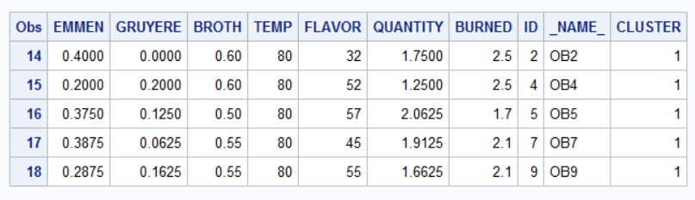

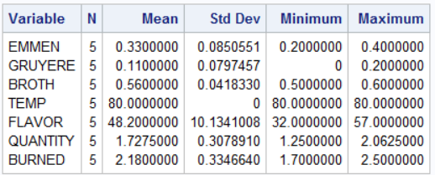

Cluster 2 has the observations (11,13,14,16,18) shows the highest TEMP mean value at 90 and lowest QUANTITY mean value at 0.6. The mean values of EMMEN and GRUYERE are the same as cluster 1 at 0.33 and 0.11 respectively. Cluster 2 also has the highest mean value for BURNED at 2.84.

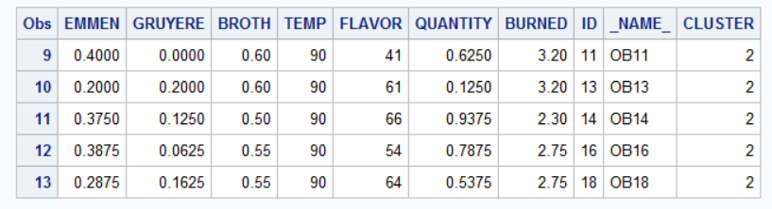

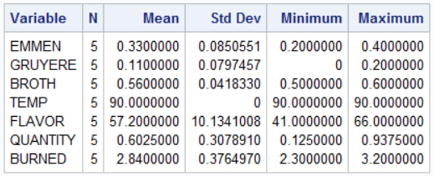

Cluster 3 has the observations (3,8,12,17) shows the highest mean value for GRUYERE and FLAVOR at 0.25 82.5 respectively. The mean values for broth and temperature are similar to the values in cluster 4.

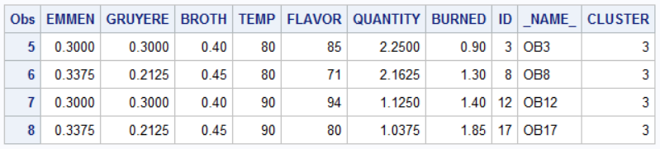

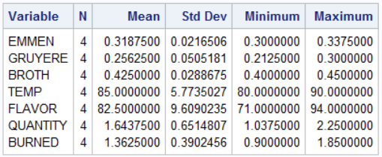

Cluster 4 has the observations (1,6,10,15) shows the highest mean for EMMEN at 0.54 and the lowest GRUYERE at 0.03. The mean values for broth and temperature are similar to the values in cluster 3.

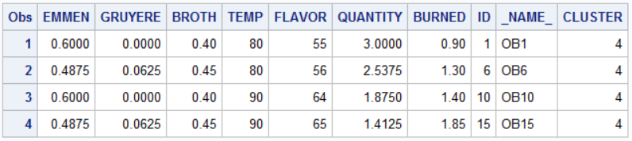

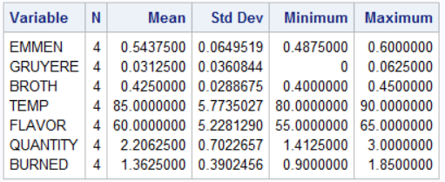

**Appendix**

This is the SAS output for PROC CLUSTER

